Snort - Intrusion Detection

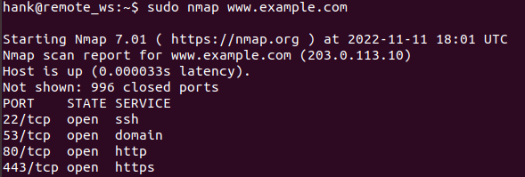

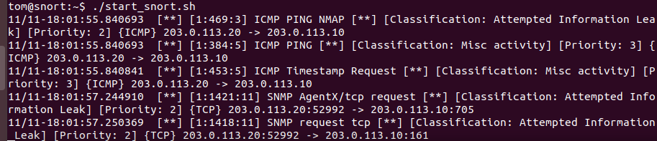

Performed nmap scan on [www.example.com.](http://www.example.com.) Snort was able to detect and alert of incoming nmap.



Wrote new rule into local.rules

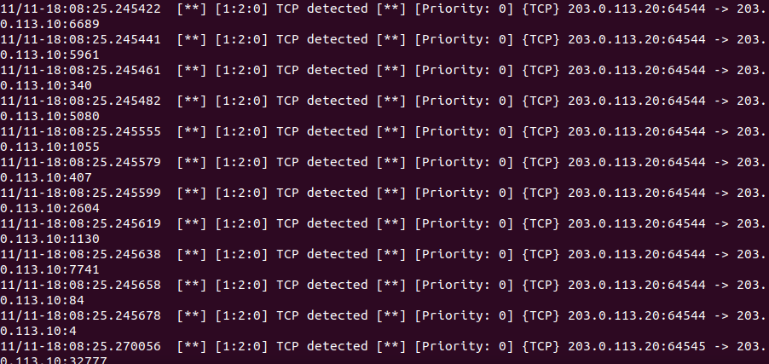

Snort is now flooded with alerts of TCP traffic detected.